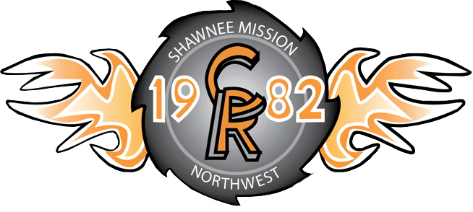
SMNW Team 1982
US First Robotics League
12701 W 67th St.
Shawnee, KS 66216

Greetings from Cougar Robotics Team 1982! The 2014 build season has kicked off announcing the new game mode: Aerial Assist! Our members have been consistently busy at work, prototyping our next robot and brainstorming new strategies for approach. As we anticipate the 6 week deadline, we’d like to take the time to debrief in retrospect of the previous season to our current state of progress.
Cougar Robotics participated in the Greater Kansas City Regional for the 2013 season. Over the three day competition, we were able to view robots from more than 50 teams; by observing their unique abilities we may be able to apply similar strategies to future challenges.
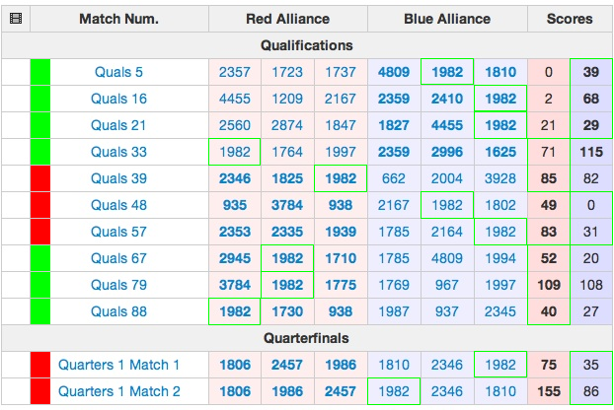
Our team was very successful during qualification matches. Winning 7 out of the 10 matches, we managed to place 13th overall. We were drafted by the 8th seat for the elimination rounds; however we were put face to face with the first seat for the first quarter-final matches. We had potential to win the first match though faltered through penalties and the second match followed through similarly in defeat. We were very satisfied to have made it into the elimination bracket, and proudly claim our efforts.
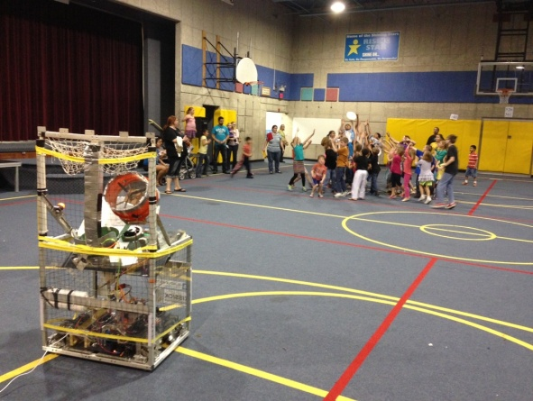
Beside the competitive portion of the season, 2013 was very progressive year in other sectors. We had rebuilt our website from the ground up, redesigning our once raw homepage to an organized hub with information of FRC resources and our team’s history. We also began reaching out into the community to spread the message of FIRST and its significant education to students. We participated in multiple events such as the showing of our robot at Rising Star Elementary.
On November 1st and 2nd, Cougar Robotics participated in Lee Summit’s annual off-season competition, Cow Town Throwdown. Winning about half of our qualification matches, we placed in the top 15 overall. We were chosen for the elimination matches by Team SWAT 1806, which robot was capable of full court scoring. We made it to the final bracket to place second in closely scored matches against Team Titanium’s alliance. We were very proud to place among such innovative and prestigious robots.
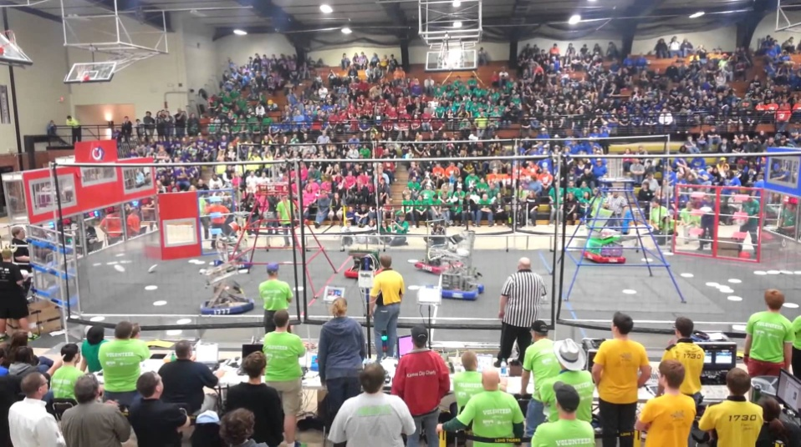

As of the publishing of this newsletter on January 18, 2014, we are starting our third week of the build season. We had identified our weaknesses of last year prior to kick-off, and have prototyped the main functional components for our robot successfully. We aim to register for a second competition, the regional in Denver, Colorado by continuing to contact local businesses for funding before our deadline on January 23rd. The season is still young and we look towards competition with excitement.
To learn more about our team, visit www.nwcougarrobotics.com. We will be posting on our website extensively to provide pictures and updates of our progress with more information as the season continues. Game information can be found linked from the front page and our blog by clicking ‘Team Area’. We look forward to arranging more sponsorships and collaborations with the community.

